**DQWG14-08C**

## Paper for consideration by Data Quality Working Group

## Proposal for a new method to display quality information

|  |  |
| --- | --- |
| ***Submitted by:*** | DQWG Chair |
| ***Executive Summary:*** | Paper proposing a new method to display quality information. |
| ***Related Documents:*** | S52 Pres.Lib.Ed 4.0.2. Part I, S52 Pres.Lib.Ed 4.0.2. Part I Addendum, S-101 Data Classification and Encoding Guide_1.0.0_Clean_20181022, NCWG3-08.4A, HSSC9-05.2D |
| ***Related Projects:*** | HSSC10/47 |

## Introduction / Background

At HSSC-1 (22-24 October 2007) a revised DQWG Work Plan was proposed and endorsed, including defining a better way of depicting to the mariner the quality of the underlying data that has been compiled into the chart or ENC. This resulted into a new task at HSSC-9 (6-10 November 2017). DQWG was requested to develop a conditional visualization methodology of quality of bathymetric data in liaison with NCWG, NIPWG, ENCWG, S-101PT. At HSSC-9 it was decided that any legal advice are not within the Terms of Reference of the DQWG. Legal impact for Mariner and/or Hydrographic Office are out scope for DQWG.

## Analysis/Discussion

The list below shows the various efforts that have been made by DQWG to depict quality in the past and reported at HSSC:

* “The fundamental problem is to define a better way of depicting the quality of the underlying data that has been compiled into the chart of or ENC to the mariner.” (HSSC1-06.6A rev.2).
* “The DQWG concluded that to support future expected uses of data quality in S-101, hydrographic offices should populate POSACC, SOUACC and TECSOU in M_QUAL if these values are better than specified by the CATZOC shown for the area. This will allow S-101 to build a different (as yet undecided) composite data quality indicator from S-57 data sets.” (HSSC3-05.6A).
* “The University of Southern Mississippi (USM) propose a two stage approach: stage 1 will visualize individual data quality indicators (e.g. color banding based upon horizontal uncertainty). Stage 2 will look at how these individual visualizations can be combined to provide a composite indicator.” (HSSC4-05.6A).
* “Essentially the findings of USM confirmed that the concept of representing data quality by a color wash overlay of red for poor, yellow (amber) for medium and green (or clear) for good is the most intuitive and clearest means of doing so.” (HSSC5-05.6A)
* “One conclusion from this work was that the long held view that the final data quality display should be a red, amber or green color wash overlay was abandoned.” (HSSC6-05.6A rev.1).

The current system consists of S-57 data objects, attributes and S-52 presentation library. The current method to portrayal data quality is by activating the M_QUAL meta object with symbols for CATZOC. Below a list of characteristics of the S-52 Presentation Library:

|  |  |  |  |  |  |
| --- | --- | --- | --- | --- | --- |
| **CATZOC** | **symbol name** | **symbol explanation** | **symbol size** | **color** | **pattern** |
| A1 | DQUALA11 | 5m accuracy, full seafloor coverage | 16.97x11.84 | CHGRD | constant staggered |
| A2 | DQUALA21 | 20m accuracy, full seafloor coverage | 16.97x11.84 | CHGRD | constant staggered |
| B | DQUALB01 | 50m accuracy, lines of soundings | 16.97x11.84 | CHGRD | constant staggered |
| C | DQUALC01 | low accuracy or incomplete chart | 16.04x4.30 | CHGRD | constant staggered |
| D | DQUALD01 | unreliable chart | 16.04x4.30 | CHGRD | constant staggered |
| U | DQUALU01 | chart with quality not assessed | 16.04x4.30 | CHGRD | constant staggered |

**Table1: list of S-52 symbols for M_QUAL/CATZOC**

Symbols A11, A21 and B01 have a constant staggered pattern type with a distance of 14.00 mm. Symbols C01, D01 and U01 have a constant staggered pattern type with a distance of 16.00mm. Line weight of all symbols is 0.3 mm. Below a depiction of these symbols in an ENC.

|  |
| --- |
|  |
| *Zones Of Confidence symbols, categories and depiction on an ENC.* |

**Figure 1: ENC ZOC symbols on an ENC**

The depiction is a constant and staggered pattern. This has the following disadvantages:

* the boundary of the area that the symbol is valid for is not clear;
* there is no direct visible relation between the size of the symbol and the area it is valid for;
* there may be a small area in-between the symbols with a different quality value;
* there are two types of symbols, a triangle and rounded rectangle, there are six different quality values;
* the number of * inside the symbols are not easy to differentiate;
* the size of the symbol is relatively large (in mm), when zooming in the symbol can be depicted over two different quality levels. The value at the pivot point of the symbol is taken and displayed. This can lead to serious misinterpretations of the quality of the underlying data.

**Relationship between the DQWG and NCWG.**

The primary objective of the DQWG is to develop appropriate methods of classifying and depicting the quality of digital hydrographic information.

The primary objective of the NCWG is to provide expert and authoritative advice and guidance to relevant IHO bodies and non-IHO entities on the concepts of nautical cartography, including the development of specifications for symbolization of any data required to be displayed on nautical charts.

Germany has provided a paper for consideration by NCWG (NCWG3-08.4A) with a proposal of a new portrayal solution for data quality indicators. See the paper for full details. The following recommendation was made:

“ The result of the research should be considered during the future development of the portrayal solution for data quality for S-101 ENCs. If S-52 for S-57 ENCs would ever experience revision in the future, this proposal should be considered for the applicability to existing ECDIS systems as well.”

**End users perspective on ENC and ECDIS**

Intertanko has submitted a paper (HSSC9-05.2D) making reference to IHO CL50/2017. The paper has the following items to note:

* safety contour and safety depth;
* quality of ENC data;
* marking in ECDIS and charts;
* spot soundings in presentation library 4.0

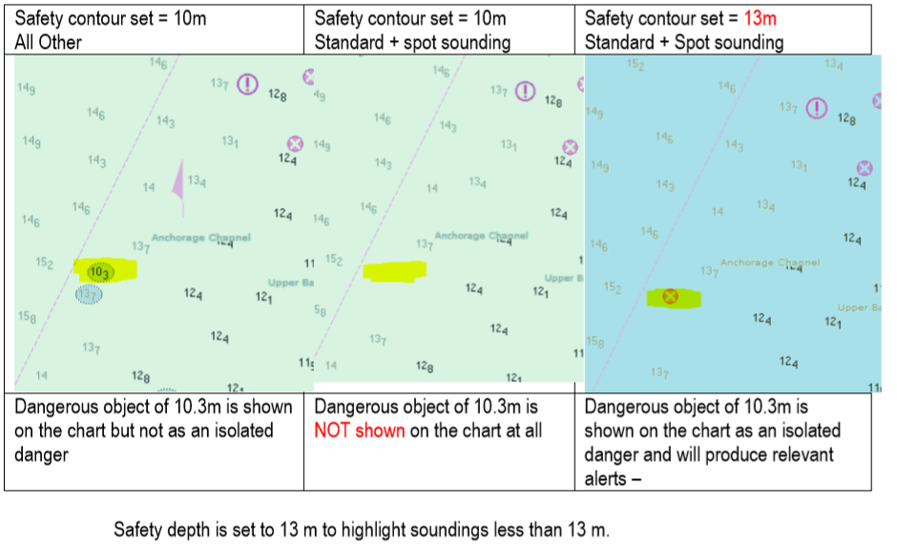

**Figure 2: marking in ECDIS and charts**

Above some images presented in this paper.

Comment from Intertanko: “It’s very difficult to understand how it has been made selectable for obstructions with soundings in the ECDIS charts. This can prove to cause groundings if this has been unticked by mistake.”

**ECDIS Performance Standards**

The IMO Performance Standard for ECDIS MSC.232(82), clause 11.3.5 Route planning states:

“An indication should also be given if the Mariner plans a route closer than a user-specified distance from a point object, such as a fixed or floating aid to navigation or isolated danger”.[1]

Clause11.4.6 Route monitoring states:

“An indication should be given to the Mariner if, continuing on its present course and speed, over a specified time or distance set by the Mariner, own ship will pass closer than a user- specified distance from a danger (for example obstruction, wreck, rock) that is shallower than the Mariner's safety contour or an aid to navigation”[2].

Current ECDIS systems allow for the Mariner to enter various user settings[3]:

The following global parameters carrying Mariner’s selection are used by the procedures:

* SAFETY DEPTH: selected safety depth (meters);
* SHALLOW_CONTOUR: selected shallow water contour (meters) (optional);
* SAFETY CONTOUR: selected safety contour (meters);
* TWO_SHADES: flag indicating selection of two depth shades (on/off);
* SHALLOW_PATTERN: flag indicating selection of shallow water highlight (on/off) (optional);
* SHIPS_OUTLINE: flag indicating selection of ship’s scale symbol (on/off);
* DISTANCE_TAGS: selected spacing of “distance to run” tags at a route (nm);
* TIME_TAGS: selected spacing of time tags at past track (min);
* FULL_SECTORS: show full length light sector lines.

The manufacturer default settings are:

* SAFETY DEPTH = 30 meters.
* SHALLOW CONTOUR = 2.0 meters.
* SAFETY CONTOUR = 30 meters.
* TWO_SHADES = on.
* SHALLOW_PATTERN = off.

**Proposal for the development of the conditional visualization methodology of quality of bathymetric data**

The existing way of depicting quality of data is done by an overlay staggered pattern in grey color. However, the Data Quality Indicator (DQI) is always turned off during execution of the voyage as it clutters the screen. A complete different approach would be to incorporate the available horizontal uncertainty directly into the depiction of the ENC. Existing Conditional Symbology Procedures (CSP) can already do that, but lack the necessary data input (the object and attribute fields are available but optional).

The development of the conditional visualization methodology should:

1. not have an impact on validity of current ECDIS certificates held by Mariners;
2. be usable in day, dusk and night environment (all palettes);
3. not create confusion with existing symbols and CSP’s;
4. improve route planning;
5. provide a clear indication of the allowable distance to obstructions, wrecks and under water rocks;
6. keep the end user at all times in control of the information provided to him to make good judgement;
7. not create additional (audible) alarms as this may lead to alarm fatigue.

In order to develop a new Conditional Symbology Procedure (CSP), first examine the existing CSP’s (the suffix ‘nn’ refers to the current edition of the CSP).[4]

**Current CSP’s related to Data Quality**:

* **QUAPOS01**: quality (accuracy) of position;

The attribute QUAPOS, which identifies low positional accuracy, is attached to the spatial object, not the feature object. This procedure passes the object to procedure QUALINnn or QUAPNTnn, which examines the spatial attributes, and returns the appropriate symbolization to QUAPOSnn.

* **QUALIN01**: quality of position of line objects;

The attribute QUAPOS, which identifies low positional accuracy, is attached only to the spatial component(s) of an object. A line object may be composed of more than one spatial components. This procedure looks at each of the spatial components, and symbolizes the line according to the positional accuracy.

* **QUAPNT02**: quality of position of point and area objects;

The attribute QUAPOS, which identifies low positional accuracy, is attached only to the spatial component(s) of an object. This procedure checks whether the mariner has requested that the symbol SY(LOWACC01) is to be shown; retrieves any QUAPOS attributes; and returns the appropriate symbols to the calling procedure.

**Current CSP’s related to Under Keel Clearance (UKC)**:

* **DEPARE03**: depth area color fill and dredged area pattern fill;

An object of the class "depth area" is colored and covered with fill patterns according to the mariner's selections of shallow contour, safety contour and deep contour. This requires a decision making process provided by the sub-procedure "SEABED01" which is called by this symbology procedure. Objects of the class "dredged area" are handled by this routine as well to ensure a consistent symbolization of all areas that represent the surface of the seabed.

The safety contour will be constructed using the edges of the DEPARE and DRGARE objects. The safety contour may be labelled at the request of the mariner using sub-procedure “SAFCON01”.

Based on the safety contour value entered by the mariner (see IMO PS [2]), the edges that make up the safety contour must be shown under all circumstances. But, while the mariner is free to enter any safety contour depth value that he thinks is suitable for the safety of his ship, the SENC only contains a limited choice of depth contours. This symbology procedure examines each edge of the DEPARE/DRGARE object to see if it falls between safe and unsafe water. If it does, that edge will represent the safety contour selected, or the next deeper contour if the selected contour is not available. It is highlighted as the safety contour and put in DISPLAYBASE. Note that this procedure will also detect the need for a safety contour at the edge of non-navigable rivers, canals or docks which must have a LNDARE or UNSARE under them (UOC 4.6.6.3, 4.6.6.5, 4.7.6, 4.7.8 and 4.8.1 remarks 2 etc.), as well as at another DEPARE/DRGARE edge.

The procedure also checks whether the edge has a ‘QUAPOS’ value indicating unreliable positioning, and if so symbolizes it with a double dashed line.

* **DEPCNT03**: depth contours, including safety contours;

This procedure symbolizes contours, identifies any line segment of the spatial object that has a 'QUAPOS' value indicating unreliable positioning and symbolizes it with a dashed line, and labels the value of the contour on demand by the Mariner. The contour may be labelled at the request of the Mariner using sub- procedure “SAFCON01”.

* **DEPVAL02**: depth value;

If the value of the attribute VALSOU for a wreck, rock or obstruction is missing/unknown, CSP DEPVAL will establish a default 'LEAST DEPTH' from the attribute DRVAL1 of the underlying depth area, and pass it to conditional procedures OBSTRN and WRECKS. However this procedure is not valid if the value of EXPSOU for the object is 2 (object is shoaler than the DRVAL1 of the surrounding depth area), or is unknown. It is also not valid if the value of WATLEV for the object is other than 3 (object is always underwater). In either of these cases the default procedures in conditional procedures OBSTRN and WRECKS are used.

* **SAFCON01**: contour labels, including safety contour;

This conditional procedure will create a list of symbol names selected that will be displayed at the mid-point of the edge.

* **SEABED01**: color fill for depth areas;

This conditional procedure will create a Color fill for depth areas (S- 57).

* **SNDFRM04**: symbolizing soundings, including safety depths;

Soundings differ from plain text because they have to be readable under all circumstances and their digits are placed according to special rules and according to the location of the feature object. This conditional symbology procedure accesses a set of carefully designed sounding symbols provided by the symbol library and compiles them into sounding labels. It also symbolizes swept depth and special symbols representing low reliability as indicated by attributes QUASOU, TECSOU, STATUS and QUAPOS.

* **SOUNDG03**: entry procedure for symbolizing soundings.

In S-57 soundings are elements of sounding arrays rather than individual objects. Thus this conditional symbology procedure examines each sounding of a sounding array one by one. To symbolize the depth values it calls the procedure SNDFRM04 which in turn translates the depth values into a set of symbols to be shown at the soundings position.

**Current CSP’s related to XTD**:

* **OBSTRN07**: obstructions and under water rock;

Obstructions or isolated underwater dangers of depths less than he safety contour which lie within the safe waters defined by the safety contour are to be presented by a specific isolated danger symbol and put in IMO category "DISPLAY BASE" (see IMO Performance Standard for ECDIS [2]). This task is performed by the most recent edition of sub-procedure UDWHAZnn which is called by this symbology procedure. Objects of the class "under water rock" are handled by this routine as well to ensure a consistent symbolization of isolated dangers on the seabed.

The current UDWHAZnn also allows the mariner the option of displaying isolated dangers in the waters between the safety contour and the zero meter line.

In the case that the value of attribute VALSOU for this object is unknown, the most recent edition of sub-procedure DEPVALnn is called. This will provide a default 'least_depth' from the DRVAL1 of the underlying depth area on condition that the value of attribute EXPSOU is not 2 (shoaler than the depth area), and the value of attribute WATLEV is 3 (always underwater).

* **UDWHAZ05**: isolated dangers in general that endanger own ship;

This procedure covers “Isolated dangers in general that endanger own ship (S-57).” (Note that this is a sub procedure called by OBSTRNnn and WRECKSnn). Obstructions or isolated underwater dangers of depths less than the safety contour which lie within the safe waters defined by the safety contour are to be presented by a specific isolated danger symbol as hazardous objects. They are then put in IMO category “DISPLAY BASE” (see IMO Performance Standards for ECDIS [2]).

In addition, if the mariner selects the option "show isolated dangers in shallow water", this procedure will highlight with the isolated danger symbol all rocks, wrecks, obstructions, which lie in 'unsafe' shallow waters between the safety contour and the drying line, putting them in IMO category STANDARD. This option is provided in case the mariner is forced by circumstances to navigate in waters shallower than the safety contour shown on the display (for example, if the safety contour should default to a value much deeper than that preferred by the mariner).

In this procedure the term “safety contour” refers to the safety contour selected by the mariner, as distinct from the safety contour shown on the display (which may be a default value).

* **WRECKS05**: wrecks.

This procedure covers “Isolated dangers in general that endanger own ship (S-57).” (Note that this is a sub procedure called by OBSTRNnn and WRECKSnn). Obstructions or isolated underwater dangers of depths less than the safety contour which lie within the safe waters defined by the safety contour are to be presented by a specific isolated danger symbol as hazardous objects. They are then put in IMO category “DISPLAY BASE” (see IMO Performance Standards for ECDIS [2]).

In addition, if the mariner selects the option "show isolated dangers in shallow water", this procedure will highlight with the isolated danger symbol all rocks, wrecks, obstructions, which lie in 'unsafe' shallow waters between the safety contour and the drying line, putting them in IMO category STANDARD. This option is provided in case the mariner is forced by circumstances to navigate in waters shallower than the safety contour shown on the display (for example, if the safety contour should default to a value much deeper than that preferred by the mariner).

In this procedure the term “safety contour” refers to the safety contour selected by the mariner, as distinct from the safety contour shown on the display (which may be a default value).

**Shared sub-procedures**:

Some basic procedures are used in more than one application. For example, SNDFRMnn is called by soundings, wrecks, rocks and obstructions to compose depth values into soundings. Such shared sub-procedures can only be accessed through a calling procedure; they cannot be called directly from the look-up table. When necessary, an entry procedure is set up solely to give this access.

The following table explains these relationships:

| **S-57 Object**  **(Geometry)** | **CSP name** | **Sub-procedure name** | **Notes** |
| --- | --- | --- | --- |
| DEPARE (a) | DEPARE03 | SEABED01 |  |
| DRGARE (a) | SAFCON01 |  |
| DEPARE (l) | DEPCNT03 | SAFCON01 |  |
| DEPCNT (l) |  |
| OBSTRN (p/a) | OBSTRN07 | DEPVAL02 | sub-procedure also called by WRECKS05 |
| QUAPNT02 | sub-procedure also called by QUAPOS01 & WRECKS05 |
| UWTROC (p) | SNDFRM04 | sub-procedure also called by  SOUNDG03 & WRECKS05 |
| UDWHAZ05 | sub-procedure also called by WRECKS05 |
| LNDARE (p/a) | QUAPOS01 | QUAPNT02 | sub-procedure also called by  OBSTRN07 & WRECKS05 |
| COALNE (l) | QUALIN01 |  |
| SOUNDG (p) | SOUNDG03 | SNDFRM04 | sub-procedure also called by  OBSTRN07 & WRECKS05 |
| WRECKS (p/a) | WRECKS05 | DEPVAL02 | sub-procedure also called by  OBSTRN07 |
| QUAPNT02 | sub-procedure also called by  QUAPOS01 & OBSTRN07 |
| SNDFRM04 | sub-procedure also called by  OBSTRN07 & SOUNDG03 |
| UDWHAZ05 | sub-procedure also called by  OBSTRN07 |

**Table 2: shared sub procedures (CSP’s)**

note: p=point geometry, l = line geometry, a = area geometry

**Proposal 1: show depth contours with low accuracy during execution of voyage**

This proposal is based on the existing CSP DEPCNT03 and will use S-101 Metadata feature: Quality of Bathymetric Data (M_QUAL)

The existing DEPCNT03 acts as follows:

| **step** | **Loop entry point** | **For each spatial component of this object, perform this loop.** |
| --- | --- | --- |
| 1 | Get ‘QUAPOS’ | Get the value of the Attribute 'QUAPOS' of the current spatial component. |
| 2 | Has value ('QUAPOS')? | Is the value of the attribute 'QUAPOS' given? |
| 3 | QUAPOS' != 1 && 10 && 11? | Does the value of attribute 'QUAPOS' equal to neither of the following values: '1', '10', and '11'? |
|  |  |  |
| 4 | LS(DASH,1,DEPCN) | Symbolize the line with a dashed line, 1 unit wide, color 'DEPCN'. |
| 5 | LS(SOLD,1,DEPCN) | Symbolize the line with a solid line, 1 unit wide, color 'DEPCN'. |
| 6 | Display Contour Labels? | Has the mariner chosen to display contour labels by used of selection of viewing group 33022? |
| 7 | Has value ('VALDCO')? | Is the value of the attribute 'VALDCO' given? |
| 8 | LOC_VALDCO = 'VALDCO' | Set the local variable 'LOC_VALDCO' equal to 'VALDCO' value. |
| 9 | LOC_VALDCO = 0.0 | Set the local variable LOC_VALDCO equal to 0.0 m. |
| 10 | SAFCON01 (LOC_VALDCO) | Perform the symbology procedure 'SAFCON01' to symbolize the contour label. Pass the value of local variable 'LOC_VALDCO' to 'SAFCON01'. A list of symbols is returned. |
| LOC_VALDCO | - input parameter |
| List of Symbols | - output parameter |
| 11 | Draw Selected Symbols from 'SAFCON01' | Draw the symbols that were returned by 'SAFCON01' at the center of the run-length of the line. Symbols must be displayed upright with respect to the screen borders and not aligned along the contour. |
| 12 | continue | Go to the next spatial component. |

**Table 3: CSP DEPCNT03**

Between step 3 and 4 the following actions should be inserted:

* Has value (‘VALDCO’)?
* Is value VALDCO smaller than SAFETY_DEPTH?
* Is viewing scale larger than chart compilation scale?
* Get the value of Quality of Bathymetric Data in the same spatial domain as the contour line.
* Is there only value applicable?
* Is the value = 5 or Unassessed?
* LS (DASH,1,DEPCN)

ELSE

* LS (SOLID,1,DEPCN)

This will check for contour lines shallower than the safety depth, in case the QUAPOS value is not equal to “surveyed”, “precisely known” or “calculated”, the overall overlying quality indicator where the depth contour is situated in, having value level 5 (CATZOC=D) or Unassessed, and the Mariner has zoomed in beyond the compilation scale, it will show the depth contour a dashed line, as an indication of approximate.

Please note that the current S-101 Object Depth Contour (DEPCNT) only has two attributes:

|  |  |  |  |  |
| --- | --- | --- | --- | --- |
| **S-101 attribute** | **S-57 Acronym** | **Allowable encoding value** | **Type** | **Multiplicity** |
| value of depth contour | (VALDCO) |  | RE | 1,1 |
| scale minimum | (SCAMIN) |  | IN | 0,1 |

**Table 4: list of S-101 attributes of object Depth Contour**

The concept of Spatial Quality is defined in the S-101 Data Classification and Encoding Guide, paragraph 24.5

|  |  |  |  |  |
| --- | --- | --- | --- | --- |
| IHO Definition: **SPATIAL QUALITY**. Definition required | | | | |
| **S-101 Information Type:** Spatial Quality | | | | |
| **Primitives:** None | | | | |
| **S-101 Attribute** | **S-57 Acronym** | **Allowable Encoding Value** | **Type** | **Multiplicity** |
| horizontal position uncertainty |  |  | C | 0,1 |
| uncertainty fixed | (POSACC) |  | (S) RE | 1,1 |
| uncertainty variable factor |  |  | (S) RE | 0,1 |
| quality of horizontal measurement | (QUAPOS) | 1: surveyed  2: unsurveyed  3: inadequately surveyed  4: approximate  5: position doubtful  6: unreliable  9: estimated  10: precisely known  11: calculated | EN | 0,1 |
| vertical uncertainty |  |  | C | 0,1 |
| uncertainty fixed | (VERACC) |  | (S) RE | 1,1 |
| uncertainty variable factor |  |  | (S) RE | 1,1 |

**Table 5: S-101 Information Type Spatial Quality**

POSACC is a numerical quality indicator.

QUAPOS is a descriptive quality indicator.

**Proposal 2: display a circle of uncertainty around isolated dangers and under water rocks**

Obstructions (OBSTRN), wrecks (WRECKS) and under water rocks (UWTROC) require not only a vertical quality indicator, but also a horizontal quality indicator. Various shipping accidents have occurred because the vessel ran into an obstruction, wreck or under water rock not being in the exact position as indicated on the chart.

For the CSP’s OBSTRN07 and WRECKS05 the following checks should be added:

* is the POSACC value given?
* get POSACC value.
* apply POSACC value when calculating the safety circle.
* is the QUAPOS value given?
* is QUAPOS value not equal to precisely known or calculated?
* get the Quality of Bathymetric Data value where the isolated object is situated in.
* is the QobD value equal to 4, 5 or Unassessed? (CATZOC = C, D or Unassessed)
* get the SAFETY_DEPTH value.
* Is the least depth of the isolated danger less than the safety depth?
* get the current viewing scale.
* compute a circle using POSACC value if available, else use 500 meters.
* draw a circle around the object using a dashed line, width 0.3 mm in magenta color.
* if mariner zooms in beyond chart compilation scale, change the width of the line into 0.6 mm.
* if viewing scale changes, recalculate and redraw.

The above new CSP will draw a circle or around the isolated danger indicating a safe clearance zone of 500 meters. If the Mariner has an overview scale, the 500-meter radius will be smaller than the current symbol displaying the isolated danger and the circle has lower display priority and will thus not be visible. When the Mariner zooms in, the safety circle will appear from underneath the standard symbol. When the Mariner zooms in beyond the chart compilation scale, the width of the line drawn is doubled, thus providing a clear visible alarm (analogue to a safety contour) to the Mariner.

To illustrate these concepts, the following figures are presented:

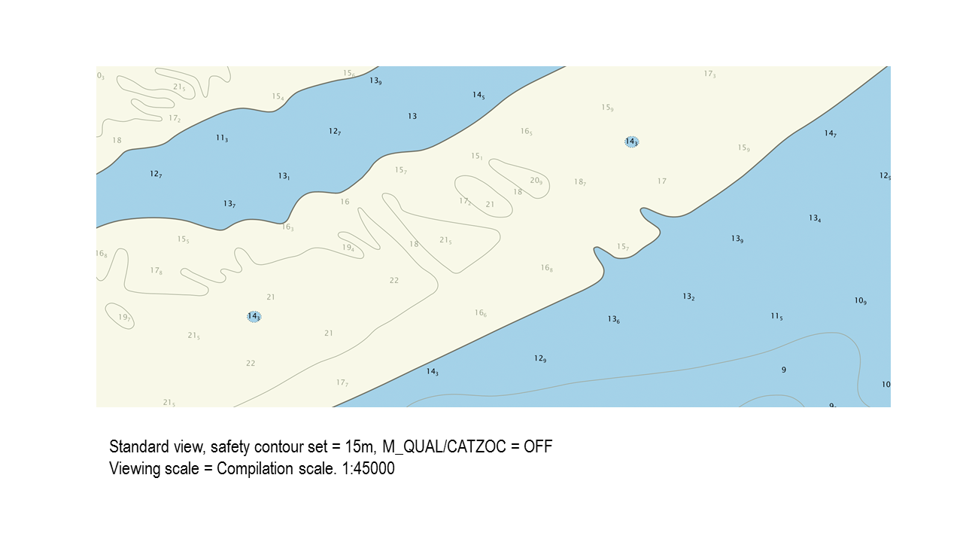

**Figure 3: current ECDIS view**

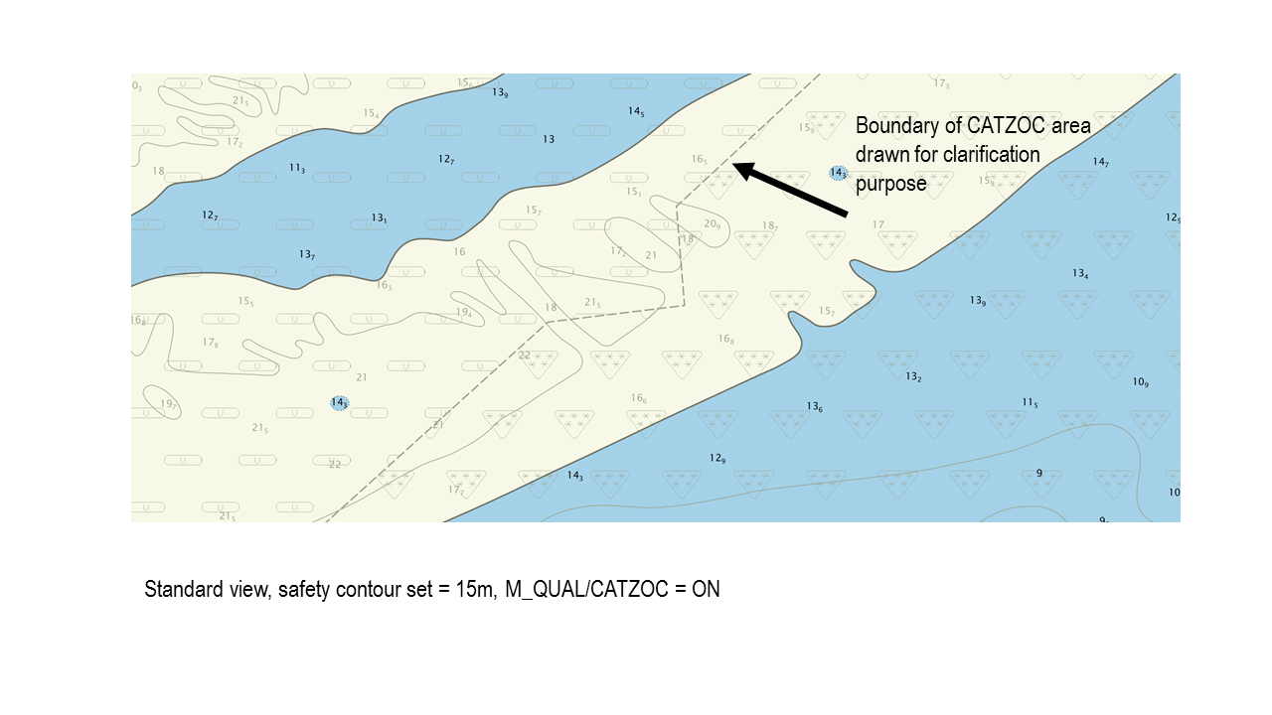

**Figure 4: current ECDIS view with M_QUAL activated.**

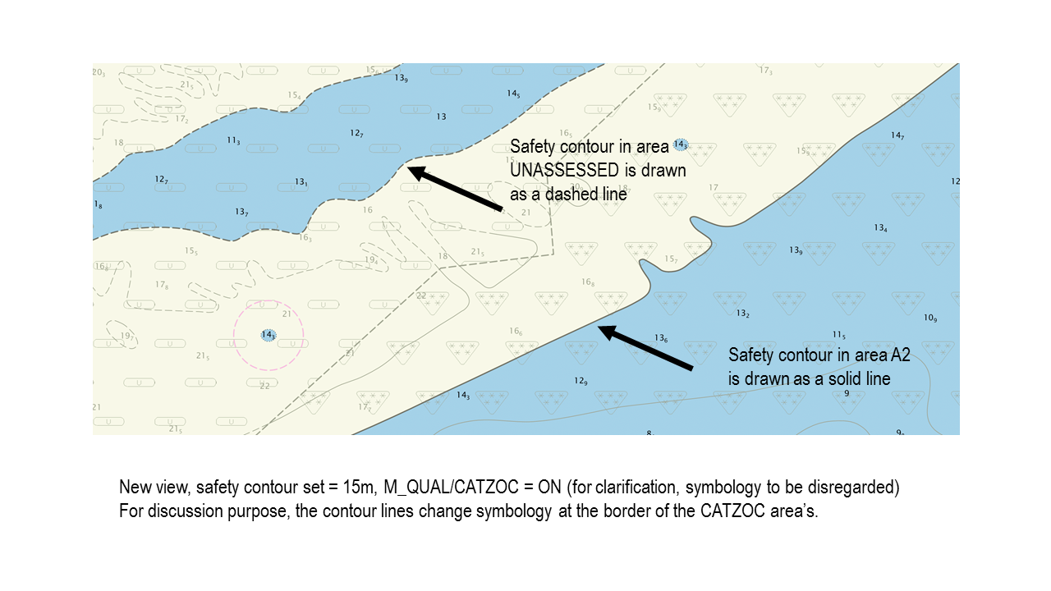

**Figure 5: New ECDIS view, M_QUAL activated for clarification purpose**

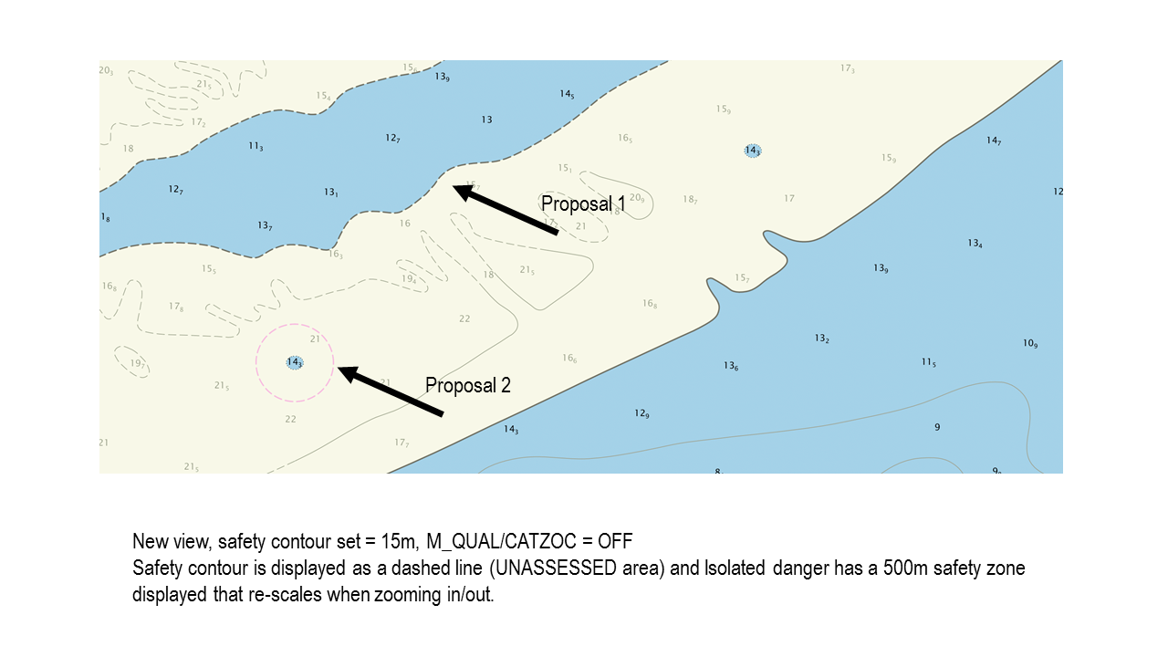

**Figure 6: new ECDIS view with dashed safety contour and safety zone around isolated danger**

## Conclusions

The existing symbology to display quality of underlying data has many disadvantages. The disadvantages listed should be eliminated by means of a more intuitive symbolization method. An overview symbolization to display quality of bathymetric information should be maintained in S-101.

During execution of a voyage, two new conditions symbology procedures are proposed. One to display depth contour lines as dashed lines in case they are smaller than the Safety Depth set by the Mariner and are in a low quality area and the Mariner has zoomed in beyond the chart compilation scale. The second proposal will draw a horizontal circle around isolated danger with unreliable positions. This circle has a size of 500 meters if the positional uncertainty is not given or not accurate and the least depth of the isolated danger is less than the safety depth entered by the Mariner.

## Recommendations

DQWG is recommended to balance the existing pro’s/con’s of showing CATZOC, the NCWG3-08.4A proposal and the proposals presented in this paper. DQWG is recommended to advice what object and attribute relationships should be made in S-101 to make full use of its capabilities with respect to Data Quality of single objects and depth areas.

## Justification and Impacts

The two proposals for CPS’s will use existing library and symbols and will work in all available palettes. The look and feel of the ECDIS system is not changed.

HO’s to reconsider assigning meaningful spatial quality values to obstructions, wrecks and under water rocks in areas shallower than 30 meters.

HSSC may consider implementing, upon agreement, (one of) the proposals into the existing S-52 Presentation Library after consultation with/agreement from the stakeholders.

## Action Required of Data Quality Working Group

The DQWG is invited to:

a. discuss this paper;

b. discuss paper NCWG3-08.4A;

c. discuss what should be advised to the NCWG w.r.t existing M_QUAL/CATZOC symbology;

d. discuss the proposal of a new conditional symbology procedure presented in this paper;

e. agree on the recommendations to the NCWG;

f. agree on the recommendations to the S-101PT;

g. agree on the report from DQWG to HSSC-11 on this subject.

Annex – A: Basic concept of ECDIS display.

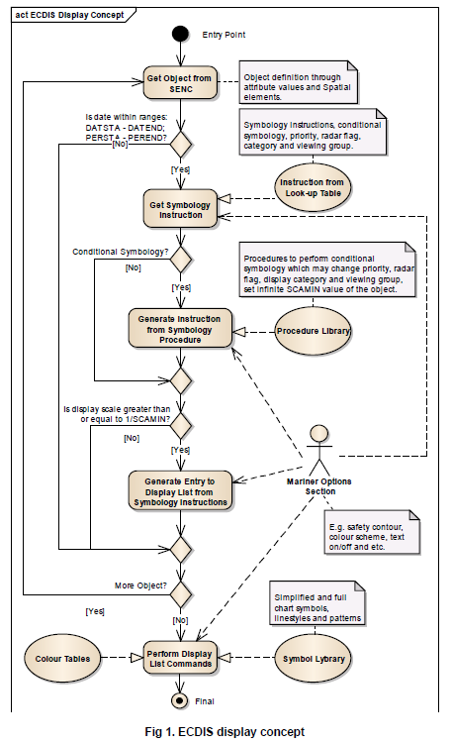

|  |  |
| --- | --- |
| Entry Point | Clipped portion of ENC to be displayed on the ECDIS screen.  Perform for each SENC object. |
| Get Object from SENC | Object definition through attribute values and spatial elements. |
| Is date within ranges:  DATSTA – DATEND;  PERSTA – PEREND? | Is the current date of presentation within the range of existence of the object?  That is, if there are values of the attributes’ pairs DATSAT – DATEND or PERSTA – PEREND then the current date is more than Start date and less than End date of the existence period of the object. |
| Get Symbology Instruction | Get symbology instructions, conditional instructions, priority value, radar flag, display category and viewing group from the appropriate line of the Look-up table file. |
| Instructions from Look-up table | Take the Look-up table file according to geometry type of the object and mariner parameters (‘simple point’, ‘pattern and boundaries’). |
| Conditional Symbology | Does a Conditional Symbology Procedure exist? |
| Generate Instructions from Symbology Procedure | Procedures to perform conditional symbology which may change priority, radar flag, display category and viewing group, set infinite SCAMIN value of the object. |
| Is display scale greater than or equal to 1/SCAMIN | Is the current display scale greater than or equal to 1/SCAMIN value from the object? |
| Generate Entry to Display List from Symbology Instructions | Add graphical primitives to the display list taking into account Presentation parameters (priority, radar flag, display category and viewing group). |
| More Object? | Are there more objects in the SENC? If it is, go to the next object. |
| Perform Display List Commands |  |
| Mariner Options Section | For example safety contour, color scheme, text on/off etc. |
| Symbol Library | Simplified and full chart symbols, linestyles and patterns. |
| Color Tables | Color tokens with XYL values for different palettes (Day, Dusk and Night palettes). |
| Final | Final presentation of the SENC. |

**Table 6: ECDIS display concept**

The basic concept of ECDIS display is as follows:

1. The ECDIS determines which feature objects contained within the SENC are required for display.
2. The ECDIS maintains a set of Mariner defined parameters (such as safety contour, safety depth, display category).
3. Each feature object, whether point, line or area geometric primitive are transformed into symbolization instructions using lookup tables and conditional symbology procedures described in this document.
4. The symbolization instructions are drawn to the screen using lookup tables to define color values for the selected pallet and taking into account data-defined parameters, which may affect display, such as DATSTA-DATEND and SCAMIN.

If, for example, the Mariner subsequently selects another safety contour, the list of symbolization instructions are renewed and the depth areas distinguishing shades are changed by a symbology procedure which is called to generate symbology instructions for the object class DEPARE (depth area). There are many display options, some of which are mandatory and which are described in this document. The ECDIS manufacturer is also able to provide Mariner features within their ECDIS which build on the mechanisms described in this document.

Note that the ECDIS must not initiate any change of state automatically or by linkage, for example it must not automatically select “lights” because the Mariner selects the night color table. All changes to the composition of the display must be initiated by the Mariner.

1. S-52 PresLib Ed 4.0.2 part I – par 10.5.9 page 71
2. Same as above.
3. S-52 PL Ed.4.0.2 part I, page 102
4. S-52 PL Ed.4.0.2 chapter 13